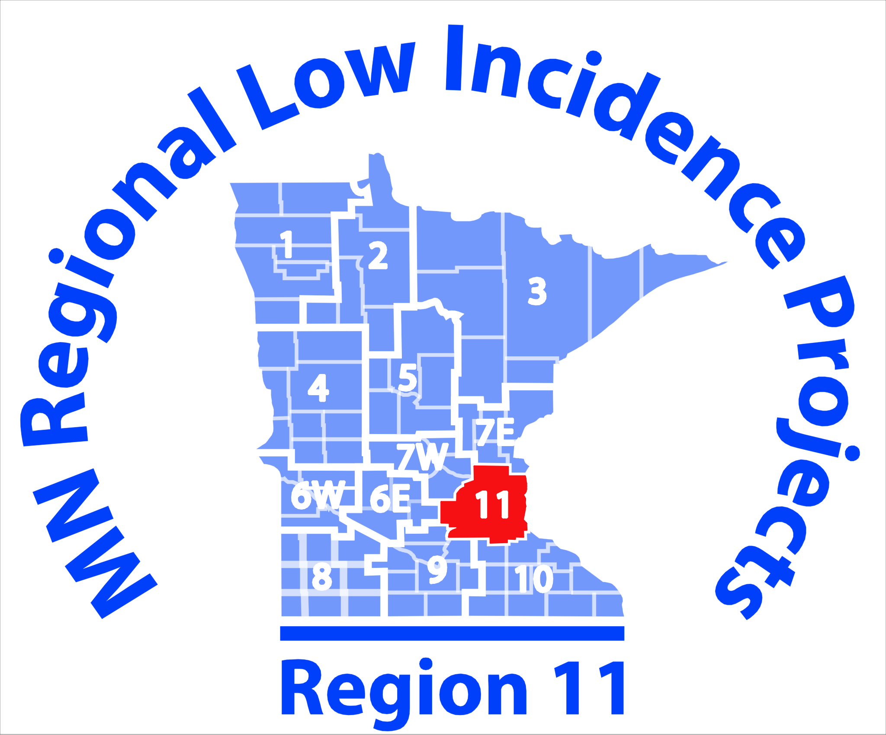
Blind/VI Community of Practice Agenda:

September 27, 2017
1:00-3:00 p.m.

Metro ECSU
Oak Room
2 Pine Tree Drive
Arden Hills, MN 55112

12:30 Bring lunch and network – optional
1:00 – 3:00 Meeting
Kelly Ward and Kim Simshauser, Co-Coaches

AGENDA
- Feedback and determine dates and places for elementary and middle school field trips
- Plan date and logistics for High School Field Trip
- Discuss Chapter 4 (Tim and Megan)
- Follow-Up discussion regarding Christine Roman Lansky Workshop
- Low Vision Clinic

Note Taker: TBD

This initiative is made possible in whole with a grant from the Minnesota Department of Education using federal funding, CFDA 84.027A, Special Education – Grants to States.

This event does not necessarily represent the policy of the federal Department of Education or the state Department of Education. You should not assume endorsement by the federal or state government.

